Kinematics Review Quiz Multiple Choice Questions
1. Two hikers set out from the same spot and arrive at the same destination but they take different routes. Which of the following quantities must be the same for both hikers?
a. | distance | d. | average speed
b. | displacement | e. | acceleration
c. | average velocity

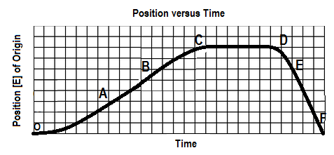
2. The graph below shows a position-time graph

Over which interval is the object moving west and speeding up?
a. OA b. BC c.CD d. DE e.EF
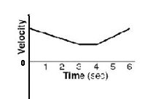

3. A velocity-time graph is shown at right. Which of following best
describes the object’s motion? The object

a. moves backward at a constant velocity, stops, then moves forward at constant velocity.
b. moves forward at a constant velocity, stops, then moves backward at constant velocity
c. slows down uniformly as it moves backward, stops, then speeds up uniformly as it moves forward
d. slows down uniformly as it moves forward, continues at a constant velocity forward, then speeds up
uniformly as it continues to move forward
e. slows down uniformly as it moves backward, continues at a constant velocity backward, then speeds
up uniformly as it moves forward

4. Which of the following graph(s) does(do) NOT represent uniform motion?
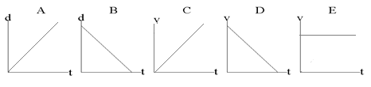

a. | A,B,C and D | d. | A and B
b. | B only | e. | C and D
c. | E only

5. The slope of a line drawn tangent to a curved position-time graph represents
a. | displacement | d. | acceleration
b. | instantaneous velocity | e. | distance
c. | average velocity

6. Which of the following are VECTOR quantities?
I. position II. speed III. displacement IV. velocity
a. I and III only d. II, III and IV only
b. III and IV only e. I, III and IV only
c. I and IV only

7. An object is travelling west and slowing down. The directions associated with the
object’s velocity and acceleration, respectively, are:
a. [W], [W] b. [W], [S] c. [W], [E] d. [E], [W] e. [E], [S]

8. The area under a velocity-time graph represents
a. | displacement | d. | instantaneous velocity
b. | acceleration | e. | average velocity
c. | change in velocity

SPH4U0-Sep 2016 Kinematics Review Quest- Name:_________________
Total: _________/42 marks [K/U]
Useful Equations:
v_{av} =ΔΔ a =ΔΔ = Δ Δd= ½ (v₁+v₂) Δt Δd=v₂ Δt – ½ a (Δt)²

Δd=v₁ Δt + ½ a (Δt)² Δd = $\frac{v22-v12}{2a}$

Part A: Multiple Choice Answers [ 8 marks]:
Write the letter representing the best answer for each question in the table below:
1 | 2 | 3 | 4 | 5 | 6 | 7 | 8

Part B: Short Answer and Problem Solving [ 26 marks]:

1. Does a car's speedometer indicate average speed or instantaneous speed? Explain. [2]

2. Is it possible for an object to have zero velocity but non-zero speed after moving over a given time
interval? If the answer is “no”, explain why this is impossible. If the answer is “yes” give an example
to support your explanation. [2]

3. A hockey puck is moving with an initial horizontal velocity of 18.0 m/s [North] over rough ice. The
frictional resistance causes a constant acceleration of 1.85 m/s² [South].
a) Find the puck's velocity after 7.0 seconds. [5]
b) Find the displacement of the puck over the 7.0 second interval. [2]

4. A child on a sled takes a running start at a toboggan run to begin sliding down the hill. They
accelerate at 1.90 m/s² as they slide down the 55.0 m long hill to reach a final velocity of 15.5 m/s at
the base of the hill. Find their initial velocity. [5]

5. A driver in a car travelling at a constant velocity forward notices a stalled truck up ahead. Due to the driver’s reaction time, it took 0.200 s for her to apply the brakes. The car then accelerated smoothly to a stop in a time of 5.0 seconds. Sketch the position-time and velocity time graphs for the motion of the car. (Although no scales are required, the time scales of the two graphs should correspond). [4]
d [forward]

v [forward]

6. A police car is at rest at a stop light when a speeding sports car passes the police car at a constant
velocity of 25.0 m/s [F]. As the sports car passes by, the police car turns on its siren and accelerates
at a rate of 2.5 m/s² [F] in hot pursuit! Determine the time required for the police car to catch the
speedster and the displacement from the stop light at which the police car catches up. [6]

Part C: Graph Analysis [8 marks]

1. The motion of a train engine moving along a straight track in a railyard is shown on the velocity-time
graph below.
i) Draw the corresponding acceleration-tine graph for the train. [3]
ii) Assuming that the train starts at the station (origin), draw the corresponding
position-time graph. [5]

Position-Time Graph:

Velocity-Time Graph:
8

4

0

-4

-8

V
(m/s)

[E]
Time
(s)
 | 1.0 |  | 2.0 |  | 3.0 |  | 4.0 |  | 5.0 |  | 6.0 |  | 7.0 |  | 8.0 |  | 9.0 |  | 10.0

Acceleration-Time Graph:

